**Assignment 33.1**

**Problem Statement:**

● Write Java client API to perform following operations:

● Create the method name get record and use get class to retrieve one record at a time record from company table.

● Create the method name display and use scan class to display all records from company table.

**Program:**

We have table ‘company’ in HBase which holds two records as below:

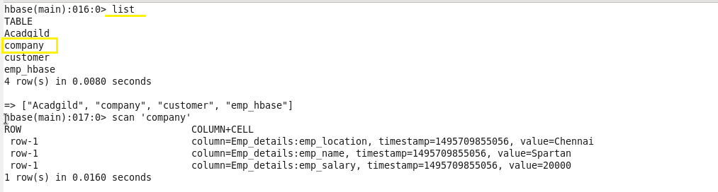

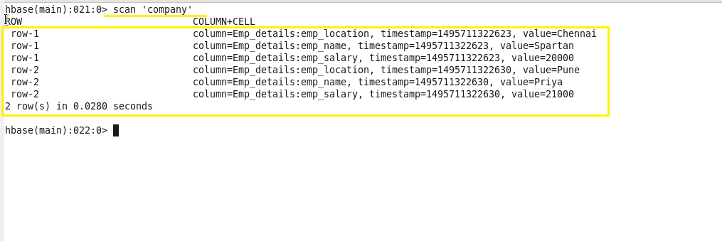

We can write java API to get the data from table **‘company’** as below:

* **Get method:**

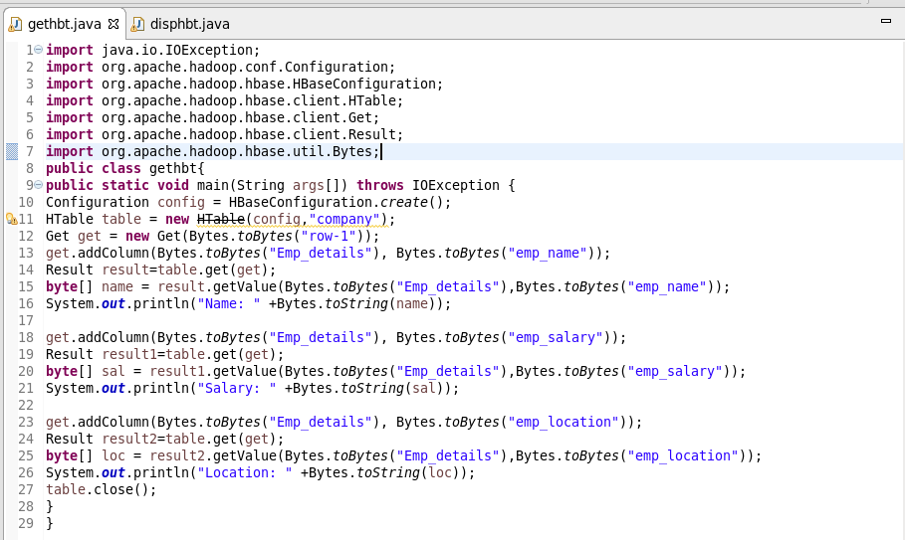

**Output:**

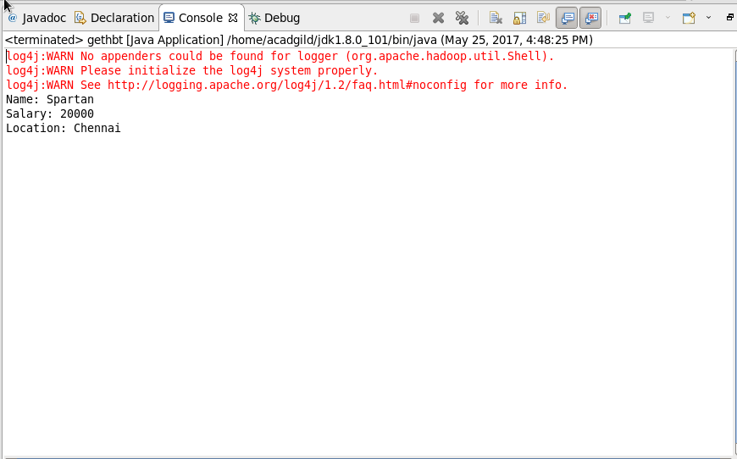

* **Display method:**

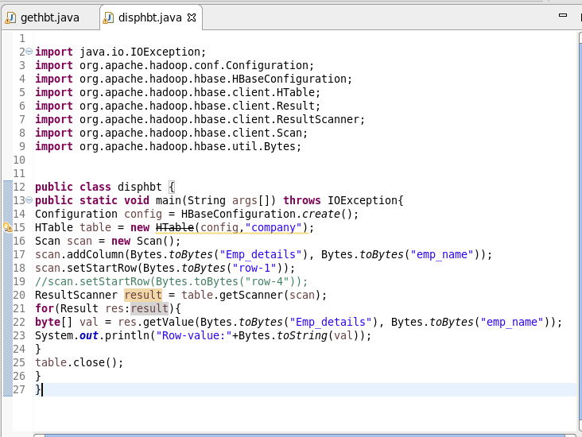

**Output:**

